Immune Disorder Practice Client
Monique- Rheumatoid Arthritis
Read up until the basic shopping list. Rest you have seen before.
My fiancé and I were at a local bike race and run in downtown Milwaukee and we ran into an old friend of mine Monique. Monique was is town for work and came out to watch the race that evening. While catching up on life over the last five to ten years we hadn’t been in contact, her ailments came up. As we talked more on her rheumatoid arthritis issues, I asked if she would want to be my subject for this class and she accepted. What I will do and propose in this paper is to evaluate Monique and develop a three-phase plan that will include an assessment of her health and lifestyle, a plan to move here towards a more healthy state, and then a plan to support her goals over time. Monique is 54 years old.

Schedule and conduct the preliminary interview. After the interview and evaluate and develop a three-phase strategic plan (phase 1 assessment, phase 2 plan, phase 3 support and follow-up), With recommendations for the client to change behavior to support health goals. Use the following protocol:
- Identify the strategies for change and support needed through the following steps at the preliminary interview:
  - Assess the clients willingness to make changes; this is important in creating a realistic protocol.
Monique met to discuss her health concerns and goals. She is very motivated and wants to get back on track with the healthy lifestyle she once enjoyed. The change in her life is not because she let things go, but because things crept up on her and now have her spectating instead of participating. She has a great understanding of what her ailments are, but to a point of extreme frustration from lack of progress. Part of the dynamic, for Monique and I, will be to do this on a budget that is appropriate for her. On the flip side, she has good insurance, that has and will continue, for us to use to get testing done that can help shed light on the situation and to monitor her progress.
  - Analyze a clients diet using your nutrient analysis software program and activity level from the food, liquid and activity form.
Monique’s three-day food log was submitted to me and put into Food Works nutritional tracking software. These findings will dictate the bulk of phase-two for Monique. Below are the tree-day averages of her log:
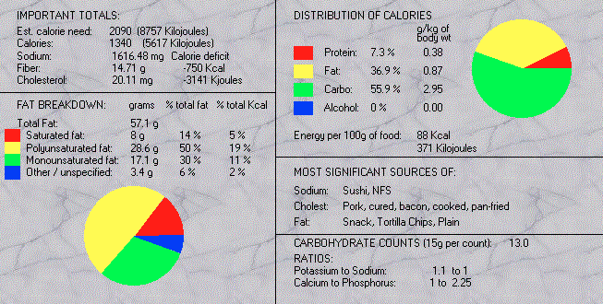
Monique’s diet will be the bulk of the changes she needs to make. Her caloric intake is well below she needs. Her average caloric intake per day was 1340 kcals, and her estimated caloric need is 2090 kcals. Her diet is also very catabolic and not supporting her bodily needs. Her macronutrient ratio’s of protein – 7.3%, fat – 36.9%, and carbohydrate – 55.9% are not in a strict catabolic direction, but when coupled with the low caloric intake I feel it is much more non-supportive for health then supportive. My initial goal will be to push this to a more building environment of 30% protein and fat, and 40% carbohydrates along with cleaning the diet up with organic, grass-fed, and non-genetically modified organisms (GMO) whole foods.
  - Evaluate the clients lifestyle.
Monique’s lifestyle was one of an avid athlete. We got to know each other racing triathlons and duathlons in the 1990’s. Before that Monique was into bodybuilding and since that she has ventured into mountain biking. Suffice it to say she is an athlete and embraces that lifestyle. I say “was” because her diagnosis of rheumatoid arthritis (RA) is what sidelined her. It is not her first health problem she has encountered in her life, it is the straw that has broke her back. It is a more recent diagnosis, relatively speaking (2006), and started with pain in her hand and moved to her wrists and the rest of her body.

At 19 years old, Monique was diagnosed with a tumor on her thyroid, which was benign. Because of this diagnosis, she spent 30 years on synthroid only recently being taken off it. She also has exercised induced asthma that started in college. Over her adult life, she has had tree surgeries for endometriosis and was put on Lupron as a result. She currently is not on Lupron. Some blood work and tests reveal that she is negative for BRCA1 gene and a celiac test was inconclusive. She does report that gluten affects her negatively and does not eat it anymore. At 27 years of age she was diagnosed with fibromyalgia. She gets ill rarely, but when she does it is awful and severe. Most recently, last March, she came down with shingles. She is currently on two medications for depression; Celexa (citalopram) and Mirtazapine. The last big lifestyle factor that will play into our protocol is the time she has spent as a metal smithing teacher. She works with many metals like copper, nickel, brass, steel, and silver.

  - Identify obstacles that you anticipate maybe encountered, and how to overcome them.
Knowing Monique and her love to move and be fit, I have no doubt she will do the work required to get back to health. The hurdles will be not to move too fast forward, address all the issues logically and progressively, and do it within her financial abilities. Starting with building Monique’s foundation of health will be my first intent. Taking a slow progressive approach of cleaning up Monique’s diet and increasing her calories with organic whole foods will support her needs. Incorporating only slow movements like walking will more than likely be all she can handle in the beginning. Keeping her from progressing too fast will be a concern of mine. We will want to be sure she is not only healing, but also that her body is in a state to take more stress of moving forward. This will take vigilance on her part and her healthcare team to include me. This will also include a time for Monique to soul search and deal with tough life decisions that she may have to make to ultimately be happy.
  - Together with the client identify and set realistic goals.
ABOVE?????
  - Provide support of materials that you have developed: educational handouts, menu plans, recipe ideas, etc.
I have included some handouts at the end of this paper to help Monique shop, eat better, develop goals, and some recipes for her to try. With Monique’s background laid out, lets get into the three phases of the plan, starting with additional assessments we can use.
Phase 1: Assessment
- Detail you suggested plan, approach and steps to support the client to achieve his/Her goal.
- Provide suggestions with brief explanations for all phases.
- Based upon your nutrient analysis report generated from the food, liquid and activity form, considered relevant nutrient rich foods, specific nutrient and/or caloric needs, dietary direction current and proposed, physical activity, nutritional supplementation, and stress management suggestions.
Further assessments can be carried out to help us formulate a plan to improve Monique’s situation. In this section I will discuss an array of options and later in the summary apply a few that are appropriate and conform to Monique’s situation and goals.

There are a number of comprehensive test we can conduct, but I feel at this time they are not warranted until we get Monique’s foundation of health built up. Some of the tests I am referring to are the cytotoxic test, RAST test, ALCAT test, and the Elisa test. I think some of these will be great to do at a later time when we have a better picture of what specifically is occurring with Monique. Another reason to wait on some of these is that with the foundation of health building phase, we may see some symptomology disappear. For now a quicker and more economical approach would be to perform the pulse test for commonly adverse foods like eggs, dairy, peanuts, soy, wheat, and fish. If we determine that there is a possible problem any of these foods we can move implement a comprehensive elimination diet to confirm its reactivity. In conjunction with this, we can have the hypoimmunity and hyperimmunity assessments by Dr. Murray completed to help us determine if there is an issue of underactive or overactive immune system function.

The only immediate tests I would like to see done are for testing for heavy metal toxicity from her job as a metal smith. She works with copper, nickel, steel, brass, and silver and here are my concerns:

Copper (Brass): as excess copper builds up in an individual’s tissues, more energy production is required in order to eliminate the accumulated excess tissue copper. However, since one of the effects of the excess copper buildup is the slowing of thyroid gland activity, the body’s capacity to produce energy is diminished. In a female with copper excess, her own estrogen production will contribute to larger and larger accumulations of excess copper. (www.nutritionalbalancing.org, 2016)

Nickle: Inhalation exposure to some nickel compounds will cause toxic effects in the respiratory tract and immune system (Smialowicz et al). Asthmatic conditions have also been documented for inhalation exposure to nickel (Goyer 1991).

Steel: I have always heard in my teachings over the years that most steel, especially American steel, has aluminum in it.

Phase 2 - Exercise and nutrition
- Detail you suggested plan, approach and steps to support the client to achieve his/Her goal.
- Provide suggestions with brief explanations for all phases.
- Based upon your nutrient analysis report generated from the food, liquid and activity form, considered relevant nutrient rich foods, specific nutrient and/or caloric needs, dietary direction current and proposed, physical activity, nutritional supplementation, and stress management suggestions.
Monique’s food log is fairly low in total calories, but that may not be as bad as it may look. She is, according to generic population comparison, about 700 kcals low on her caloric need. I would like to bring that up a bit and see how she does, but not the entire 700 kcals. I would start with 1500 kcals and focus on cleaning the foods up and getting to a protein/fat/carb ratio of 30/30/40 percent. I like starting here and observing how a person reacts. We definitely need to clean up all the categories and increase her protein, drop the fat slightly and the carbohydrates quiet a bit. While we do this the recommendations will all focus on foods and supplements that support a healthy immune system, reduce inflammation, and reduce RA symptoms. The two best things Dr. Murray states that need to be addressed for RA are (1) to identify and eliminate food allergies and (2) altering the balance of fatty acids in your body by eliminating animal products with the exception of fish from your diet.

The basics are to eat a healthy diet, get exercise, avoid toxins, maintain your appropriate body weight, and get enough sleep. Here is more detail:
NUTRITIONAL/SUPPLEMENTS
- Eat plant foods, especially green leafy vegetables. Avoid sugars and bad fats, and get enough protein and essential fatty acids. Red meat has arachidonic acid in it and that causes inflammation and should be avoided.
- Take a high potency multi-vitamin and mineral supplement. Vitamin C, E, and B vitamins, zinc, and selenium are important as well.
Sample RA protocol from Dr. Murray:
Vitamin C: 1000mg three times per day.
Vitamin E: 800IU per day
Flaxseed oil: 1tbsp daily
Bromelain: 400 mg between meals three times daily
Curcumin: 400 mg between meals three times daily
More potential herbs listed below

- Here are Dr. Murray’s recommendations for making sure you get the right amount of the right kinds of fats:
          - Reduce the amount of saturated fats and total fat and the diet when possible, choose foods that contain monounsaturated or, better still, polyunsaturated fats.
          - Eliminate margarine and other foods containing trans fatty acids and partially hydrogenated oils.
          - Take 1 tablespoon of flaxseed oil daily
          - Limit total dietary fat intake to more no more than 30% of calories per day.
          - Reduce the intake of meat and dairy products while increasing the intake of fish for higher levels of omega-3 fats.
- Eliminate common sources of food allergies such as wheat, corn, dairy products, peanuts, and processed goods with artificial coloring especially.
- Fish oil: Some preliminary studies have found that fish oil supplements may reduce rheumatoid arthritis pain and stiffness. Side effects can include nausea, belching and a fishy taste in the mouth.
- Defective manufacture of testosterone and dehydroepiandrosterone (DHEA) has been proposed as a potential predisposing factor for RA (Murray, 2000). Murray suggests talking to your physician about taking DHEA but has found that 50 mg per day has caused improvements.
- Plant oils: The seeds of evening primrose, borage and black currant contain a type of fatty acid that may help with rheumatoid arthritis pain and morning stiffness. Side effects may include nausea, diarrhea and gas.
Other foods that help all forms of rheumatoid arthritis are (Hawthorn MSHN 212 Lecture Series):
- Burdock and celery root
- Celery reduces blood pressure and acidity in the body, and cleanses the blood
- Yam (look for in Asian markets as most “yams” are sweet potatoes)
- Barley and wheat grasses help with inflammation
- Onions contain high amounts of histamine-quenching quercetin and inhibit the enzymes that produce the inflammatory prostaglandins (leukotrienes)
- Berries and cruciferous vegetables.
- Fresh ginger and pineapple

Foods to avoid with RA (Hawthorn MSHN 212 Lecture Series):
- Avoid night shades (tomato, eggplant, peppers, and potatoes) for three months to see if you are sensitive
- Avoid dairy except goat sources
- Avoid red meat and reduce animal fats as they are sources of arachidonic acid, which are transformed into inflammatory prostaglandins (leukotrienes)
- Avoid fried foods, heated oils, and sugars as they change cell membrane fluidity and impair insulin transport through the cell membranes

Fresh juices from vegetables and fruit are one of the best things you can do for your health. The enzymes, carotenes, chlorophyll, and flavonoids provide a wide assortment of health promoting compounds.
HERBS:
- Support thymus function through good diet and extra antioxidants. Use thymus extracts supplying 120 mg of pure polypeptide fractions. Astragalus root (100-150 mg three times daily) as a good alternative to thymus extract for vegetarians. (Murray, 2000)
- Ginger (200 mg of 20 percent gingerol extract three times daily). Cats claw is another herb to consider and has shown some promise in recent studies (Murray, 2000). White willow bark boiled in 750 ml water for 15-20 minutes. Divide into four doses and take 2-3 doses per day.
EXERCISE:
- Light moderate exercise- walking her dogs.
- Tai chi: This movement therapy involves gentle exercises and stretches combined with deep breathing. Many people use tai chi to relieve stress in their lives. Small studies have found that tai chi may reduce rheumatoid arthritis pain. When led by a knowledgeable instructor, tai chi is safe. But don't do any moves that cause pain.
- Increase movements over time being cognizant of frequency, duration and intensity as she builds up.

STRESS/SLEEP
- Take steps to manage stress. Practice techniques to activate the relaxation response, such as breathing exercises, visualization, or meditation. Stress is a big factor in RA.
- Avoid harmful blue light after dark. Blue blocking (470nm-480nm) lenses to protect melatonin production and to foster a good circadian rhythm.
- Having and fostering a positive attitude.
DIGESTION:
- Current research indicates that 70 percent of the immune system is located in or around the digestive system (Lipski, 2012). What trigge fuck Did you gors the autoimmune reaction is not clear, but genetic abnormalities, dietary factors, food allergies, bacterial overgrowth, “leaky gut” syndrome, and immunizations have all been suggested as possible causes (Murray, 2000). Digestive issues need to be a part of the protocol as well.
- An elimination diet can reduce inflammation and pain faster than anything else.
- Eat polyphenols to heal, soothe, and protect. Foods high in polyphenols are: berries such as strawberries, blackberries, raspberries, and blueberries. Fruits of all types like grapes cherries, Peaches, kiwi, apples, pears and plums. Other foods are green tea, black tea, ribose, mint, chocolate, coffee, onions, leeks, broccoli, cabbage, beans of all types, parsley, celery, millet, wheat, tomatoes, and clover.
- Take a probiotic of at least 1 billion 2 trillions of CFU.
- The use of immune support of foods such as whey products, colostrum, or transfer factor may be helpful for healing. Drinking raw cows or goats milk often can help healing for many people. The tryptophan in whey protein should be considered, since it can interact with SSRI’s.
- In herbal therapies, there is a group of herbs and foods called demulcents. They have a soothing effect on the gastrointestinal system. (Lipski, 2012) Some of the most common are the following: almonds, barley, burdock root, coconut oil, figs, flaxseed, oats, parsley, psyllium, pumpkin, and sage.
Phase 3 – Follow Up
The information listed so far is intentionally been a lot. It is a vast listing of things to do and lifestyle changes to make. In the summary plan forthcoming, I will select a much smaller protocol for Monique. It will take a lot of vigilance to keep Monique on track and progressing. I would recommend weekly phone calls to discuss and evaluate progress. I would also recommend the use of a nutrition tracking software like Cronometer (.com). It also has a professional version for the health practitioner to keep track and modify settings for the client. Basic meal planning would be advantageous as well. I have used an online program called RealPlans (.com) that is very flexible and functional. It produces shopping lists, has an app, and will move left overs around to other meals to fill you weekly log. If time is really a roadblock and you need meals planned even further, Blue Apron will send you organic ingredients to your door step. They come delivered with all the ingredients and cooking instructions.
Blue Apron is a great tool to get people eating better sources of food at home and not going out.

- write in 1 to 2 page summary of the recommendations for the client and the suggestions for follow-up sessions.
Initial Recommendations (6 weeks)
Dietary:

Increase caloric intake to 1500 kcals per day.

Get macronutrient ratios to 30/30/40 percent protein/fat/carbohydrates.

Clean the diet up.

- Cut the sugar cubes and white sugar entirely.
- Eat three square meals per day.
- Eat breakfast – eggs if you like them.
- Add all the whole vegetables you want, and some fruit.
- Add fish 2-3 times per week.
- Avoid: Avoid night shades (tomato, eggplant, peppers, and potatoes) for three months to see if you are sensitive.
- Avoid dairy except goat sources.
- Avoid red meat and reduce animal fats.
- Avoid fried foods, heated oils, and sugars.

Slupplementation:

Douglas Labs Immu-Support Formula (see attachment)
Vitamin C: 1000mg three times per day
Vitamin E: 600IU per day
Flaxseed oil: 1tbsp daily- recommend Udo’s Flax
Bromelin: 400 mg between meals three times daily
Curcumin: 400 mg between meals three times daily

Exercise:

Walk the dogs’ daily.

Tia chi once to twice per week if you feel you can handle it. Start with one for a few weeks when you decide to try it.

Stress and Sleep:

Add breathing exercises, visualization, or meditation to your daily routine.

Simple deep breathing: the most basic thing to remember is that your breath begins with a full exhalation in order to empty your lungs completely.

Process: sit in a comfortable position with your hands on your knees. Relax your shoulders. On your next exhalation, breathe out slowly through your nose, counting to five. Tense your abdominal muscles and drive in your diaphragm to help your lungs deflate. At the bottom of your breath, pause for two counts, then inhale slowly to the count of five. Expand your belly as you breathe then. Now close your eyes and repeat 5 to 10 times.

Digestion:

Eat polyphenols to heal, soothe, and protect. Foods high in polyphenols are: berries such as strawberries, blackberries, raspberries, and blueberries. Fruits of all types like grapes cherries, Peaches, kiwi, apples, pears and plums. Other foods are green tea, black tea, ribose, mint, chocolate, coffee, onions, leeks, broccoli, cabbage, beans of all types, parsley, celery, millet, wheat, tomatoes, and clover.
Take a probiotic of at least 1 billion 2 trillions of CFU.
Lab Tests/Questionaires:
Fill out the hypoimmunity and hyperimmunity questionnaires.
Get a heavy metal test conducted, especially for the metals she works with.
Follow-up:

Daily use of Cronometer to track your foods and macronutrient targets.

Weekly check in by phone to discuss progress and hurdles you are facing.

At six weeks we will conduct a progress assessment to validate your progress, goals, motivation.

BASIC SHOPPING LIST

Purchase these to replace what you currently purchase.
This will make a big difference in the quality of your diet.

Meats/poultry/fish – free range, antibiotic free, non GMO, 100% grassfed, and organic. www.eatwild.com is a great place to find good farmers to purchase from.

Eggs – free range, antibiotic free

Fruit and vegetables – organic if possible

Himalayan or Celtic brand sea salt – use it!

Cocounut oil – cook with it especially at high temps like frying

Organic butter or ghee – Use it and cook with it like coconut oil

Stevia – a great sweetener replacement can get flavored drops as well.

Braggs Apple Cider Vinegar – alkaline forming, Braggs is a good product.

Unpasteurized honey – good sweetener, buy local for local pollen and allergy protection.

Sprouted grain breads – sprouted. Carbs in bread easier to digest.

Quinoa pasta – better glycemic load food. (not as high insulin response) good protein source as well. Be careful first ingredient isn’t corn flour, or in it at all.

Cashews and/or almonds – good snack. Don’t over do them, and remember they are primarily fat, NOT protein. www.ZNatuals.com

Organic herbal teas– drink calming teas, chamomile and the likes for stress relief.

Oatmeal or steel cut oats

Olive oils

Balsamic vinegar

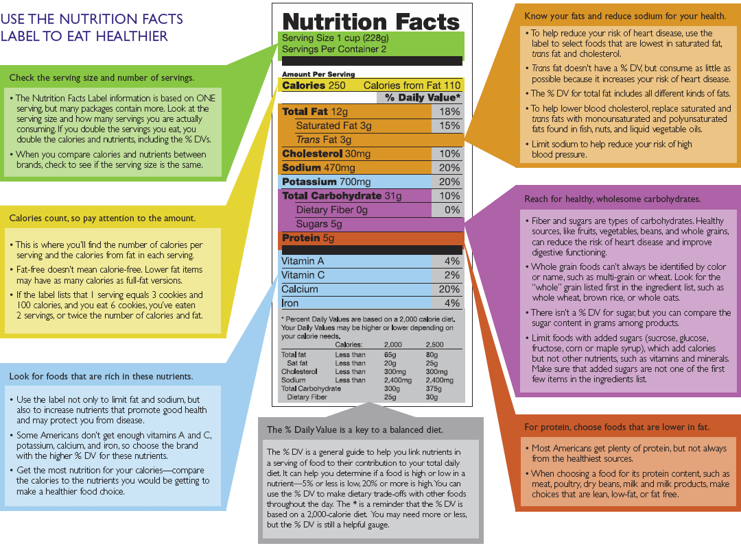

Values Worksheet
Examples of Career-Related Life Values
Friendship | To work with people I respect and to be respected by them.
Location | To be able to live where I want to live.
Enjoyment | To enjoy my work. To have fun doing it.
Loyalty | To be committed to the goals of a group of people who share by beliefs, values and ethical principles.
Family | To have time with my family.
Leadership | To motivate and energize other people. To feel responsible for identifying and accomplishing needed group tasks.
Personal Development | To learn and to do challenging work that will help me grow, that will allow me to utilize my best talents and mature as a human being.
Security | To have a stead income that fully meets my family’s basic needs.
Wisdom | To grow in understanding of myself, my personal calling and life’s real purpose. To grow in knowledge and practice my religious beliefs. To discern and do the will of God and find lasting meaning in what I do.
Community | To be deeply involved with a group that has a larger purpose beyond one’s self. To perform in effective and caring teamwork.
Wealth | To earn a great deal of money (i.e., well beyond my family’s basic needs). To be financially independent.
Expertness | To become a known and respected authority in what I do.
Service | To contribute to the well-being and satisfaction of others. To help people who need help and improve society.
Personal Accomplishment | To achieve significant goals. To be involved in undertakings I believe personally are significant – whether or not they bring me recognition from others.
Prestige | To be seen by others as successful. To become well known. To obtain recognition and status in my chosen field.
Power | To have the authority to approve or disapprove proposed courses of action. To make assignments and control allocation of people and resources.
Independence | To have freedom of thought and action. To be able to act in terms of my own time schedules and priorities.
Integrity | To live and work in compliance with my personal moral standards. To be honest and acknowledge/stand up for my personal beliefs.
Health | To be physically and mentally fit.
Creativity | To be innovative. To create new and better ways of doing things.

Top Three Values:
1)______________________________________________________________________

2)______________________________________________________________________

3)______________________________________________________________________

Bottom Three Values:

1)______________________________________________________________________

2)______________________________________________________________________

3)______________________________________________________________________

Compare your top values with those you spend the most time pursuing today. Are there any discrepancies? Are there any imbalances? What are you going to do about it?
________________________________________________________________________________________________________________________________________________________________________________________________________________________________________________________________________________________________________________________________________________________________________________________________________________________________________________________________________________________________________________________________________________________________________________________________________________________________________________________________________________________________________________________________________________________________________________________________________________________________________________________________________________________________

Douglas Labs Immu-Support Formula

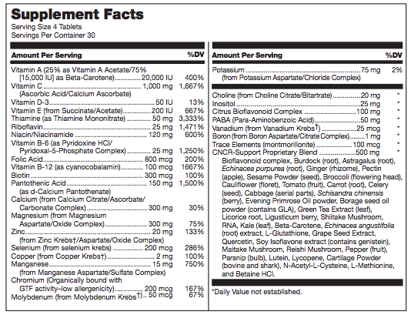

Cauliflower Pizza Crust

Ingredients for 1 pizza:
1 cup grated raw cauliflower
1 egg
1/2 cup cheese (Mexican blend tastes great but you can use any kind)
1/8 tsp garlic powder (optional)
1/8 tsp oregano (optional)
1/8 tsp basil (optional)

Directions:
Preheat oven to 425 degrees. Place parchment paper on a cookie sheet. Combine all ingredients and mix completely. Spoon mixture on prepared pan. Use the back of a spoon (or your hand) to thin out the mixture and form a square or circle about the size of a dinner plate without the rim. The thinner the crust the less chance of it being soggy. Bake for 25 minutes. Carefully flip the pizza crust over using a spatula to lift all edges of the crust off the parchment first. Bake an additional 10 to 15 minutes until edges are really brown and crisp. Even if the edges are burnt it won’t taste burnt.

Let cool just a bit. Now add whatever toppings you like (e.g., cheese, pepperoni, sausage, olives, onions, spinach). Bake 10 minutes at 425 degrees, and a few minutes on broil so the cheese (if used as a topping) is completely melted. Enjoy!

Helpful Hint:
One head of cauliflower usually makes 4-5 pizza crusts, so make several crusts at once and freeze them in gallon size Ziploc bags. You can fit them all in one bag. No need to wrap them individually either, as they won’t stick together. When ready to use one, take it out of the freezer and bake it for a few minutes to defrost. Then add toppings and bake 10 minutes at 425 degrees and a few minutes on broil.

Olive Oil Sauce:
1 tbsp olive oil
1 garlic clove, minced
1/4 tsp oregano
Pinch red pepper flakes
Salt and pepper to taste

Spinach and Goat Cheese Quiche

Servings:4
Active Time: 10 m
Total Time: 40 m

Ingredients
1 quiche crust
4 eggs
1 cup cream
1 teaspoon coarse sea salt
1/4 teaspoon ground black pepper
1/2 teaspoon paprika
1/2 onion
3 cloves garlic
1 tablespoon extra virgin olive oil
1 pound baby spinach
8 ounces goat cheese, or feta

How To Prepare
- Preheat oven to 350F.
- In a large bowl, beat the eggs and mix in the cream, salt, pepper, and paprika.
- Chop the onion and mince the garlic.
- In a pan over medium high heat, add olive oil, onions and garlic. Sauté for 3-5 minutes or until onions are translucent. Begin to add spinach and cook until it just begins to soften, about 2-3 minutes. You want the spinach softened, but not wilted by the heat.
- Crumble the goat cheese into smaller pieces.
- Evenly distribute spinach (leaving any extra liquid) and goat cheese in pre-baked crust.
- Pour egg mixture over top.
- Bake quiche for 30 minutes or until set.
Serve immediately or warm later in the oven.

REFERENCES

1. Lipski, Elizabeth. (2012). Digestive Wellness. New York, NY: McGraw Hill.
2. Murray, Michael. (2000). Total Body Tune-up. New York, NY: Bantam Books.
3. Nutritional Balancing. www.nutritionalbalancing.org, 2016.
4. The Risk Assessment Information System. https://rais.ornl.gov/tox/profiles/nickel_and_nickel_compounds_f_V1.html. Smialowicz et al. 1984, 1985, 1987; ATSDR 1988; Goyer 1991

